Explained Nonindependence

We can ask the question to what extent does the APIM explain nonindependence. Actor and partner effects, by themselves do not explain nonindependence, but rather they do so in combination with other effects. There are four ways in which the APIM explains nonindependence. First, X₁ is a common cause of Y₁ and Y₂ as below:
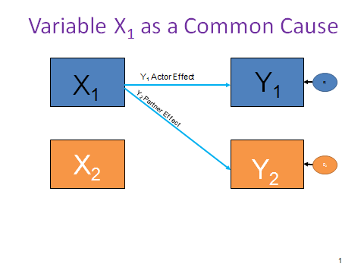
Second, X₂ is a common cause of Y₁ and Y₂ as below:
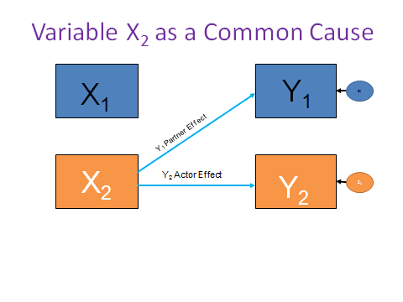

Third, there is case where there is correlation due to the two actor effects and the correlation between X₁ and X₂:
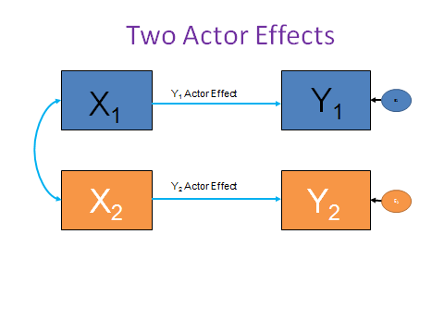
Fourth, there is case where there is correlation due to the two partner effects and the correlation between X₁ and X₂:
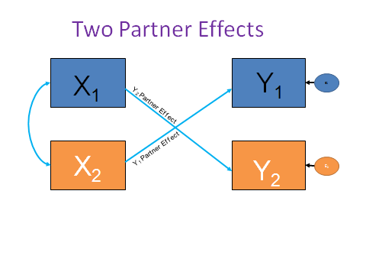

The combination of these four effects measures the total explained covariation.

Indistinguishable Dyads

The actor-partner model explains 2ap + r_{xx}(a² + p²) of the nonindependence where a and p are the standardized actor and partner effects and r_{xx} is the intraclass correlation of the actor and partner variables. (Here and below to get at the explained covariation, one needs to multiply by s_{Y}².) For the Other-Positivity and Satisfaction example, r_{xx} = .235 making the explained nonindependence .290. The unexplained nonindependence is equal to r_{ee} times 1 minus the multiple correlation for Y. However, one should not use the pseudo R² but rather the standard R² which equals a² + p² + 2apr_{xx}. Using these values for the example, the R² is .300 and the unexplained correlation is .328. If we sum the explained and unexplained nonindependence, we obtain .618, which equals the intraclass correlation for Satisfaction with no predictors.

Distinguishable Dyads

The actor-partner model explains a₁p₁ + a₂p₂ + r_{xx}(a₁a₂ + p₁p₂) of the nonindependence where a₁, a₂, p₁, and p₂ are the standardized actor and partner effects and r_{xx} is the correlation of the actor and partner variables. Note that the standardization is not across the whole sample, but with the 1s and 2s. For the Other-Positivity and Satisfaction example, r_{xx} = .235 making the explained nonindependence equals .294. The unexplained nonindependence is equal to r_{ee} times the square root of the product of 1 minus the multiple correlation of Y for the 1s and the 2s. However, one should not use the pseudo R² but rather the standard R² which equals a₁² + p₁² + 2a₁p₁r_{xx} for the 1s and a₂² + p₂² + 2a₂p₂r_{xx} for the 2s. Using these values for the example we obtain .272 for R₁² and .338 for R₂², which results in .330 for unexplained correlation. If we sum the explained and unexplained nonindependence, we obtain .623, which equals the simple correlation for Satisfaction with no predictors.

Summary

Thus, it is possible to compute the extent to which nonindependence is explained by actor and partner effects. Note that it may be the case that nonindependence might well be negative and correlation explained might be negative too.

If there are covariates, there are three additional sources of nonindependence: that due to each covariate, that due to correlation between covariates, and that due the correlation between the covariates and the mixed variables. All of these computations are now done in the app APIM_MM (https://davidakenny.shinyapps.io/APIM_MM/).

